
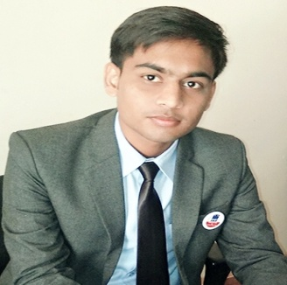
Dharmendra Kumar Pandey
Dharmendra.pandey1994@gmail.com
Mob. 09993249816
Address : A 199 Nirmal State Kausal Nagar Bhopal
Institute of Professional Education and Research (IPER) Bhojpur Road, Misrod, Bhopal (M.P.) 462026
Shalendramalviya01gmail.com
Cell: 9074942237

Objective:

- To secure a promising position that offers both a challenge and a good opportunity for growth
Academic Profile:

Exam/ Year | Institute | University/ Board | Result
M.B.A | Institute of Professional Education and Research (IPER) | Barkatullah University | 60%
B.COM | Maharaja Ranjit Singh collage of professional science Indore | Deviahiliya Viswavidyalaya Indore | 56%
12th | Sharaswati shishu Mandir vindhyanagar | M.P Board | 56%
10th | Sharaswati shishu mandir vindhyanagar | M.P Board | 59%

Trainings :

- Organization: King hills Travels Bhopal
Duration: 45Days
Roles & Responsibilities:

- To undertake the market research for the company to check its availability into the market.
- To undertake the market research for the company to know about the Customer perception.
- To Increase the Sales of Holiday package in to the Bhopal.

Projects Undertaken:

- Title: social media & its Influence in tourist destination.
Objectives: By this project, I understand the concept of online marketing Major players of this particular sector, how social media influence the tourist destination.

Co- Curricular Achievements & Activities.

- Received Cash Prize in bike race in 9th standard for highest marks.
- Certificate of appreciation from IPER Management fest “Reflation” 2015
- Ist position in HR club activity and IInd position in Finance club activity.
- Secure first position in Street play At JSS carnival 2015.
- Won the first prize in w.w.f. marketing wrestling game.
- Won the second price in slow bike race in the school level competition
COMPUTER PROFICIENCY
- Basic knowledge of MS. Excel ,Power Point, Internet
- English Typing
Personal Profile:

Strengths : Self Motivated person, Hardworking, Time Punctual
Date of Birth : 09-09-1994
Father’s name : Mr. Raj Kumar Pandey
Mother’s Name : Mrs. Lalita Pandey
Permanent Address : Flat No. 16 Shivajee Complex Navjeevan Vihar Vindhyanagar
Distt Singrauli (M.P.) PIN. 486885
Language Known : English & Hindi
Nationality : Indian

I hereby declare that the information furnished above is true to the best of my knowledge and belief.

Date: Dharmendra Kumar Pandey

